RATE YOUR PAIN

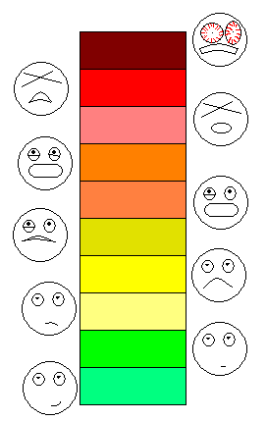

ALL ABOUT PAIN

Body’s way to tell you that something is wrong!

Do not ignore pain!

Everyone responds differently to pain!

Great clue for diagnosing injuries:

* History Question’s
  + **Type** of Pain
  + **Intensity** of Pain
  + **Constant or Intermittent**
  + **Location** of Pain
  + **Onset** of Pain
  + What **Relieves** the Pain
* Types of Pain
  + Sharp, shooting, dull, ache, throbbing, burning, zinging, constant, intermittent, stabbing, acute, chronic, pinching, tightness, prickling, pins and needles, tender, gnawing, localized, sore, pounding, deep, stretching, uncomfortable. . . .

The best way to know if you can push through pain is to know your body!

LISTEN!

10

9

8

7

6

5

4

3

2

1