Postural Deviations
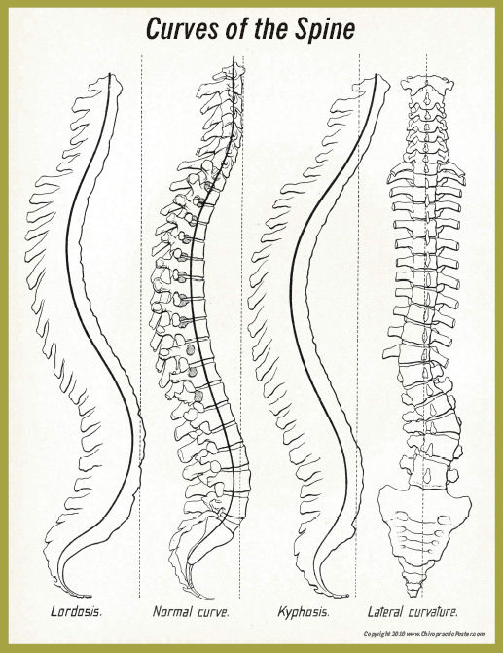

LORDOSIS

Increased lumbar curve

Adverse Effects:
Low back pain
Adaptive shortening of hip flexors
Sciatic problems
SI dysfunction

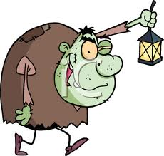

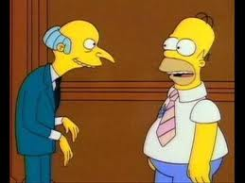

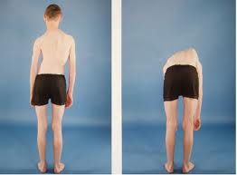

KYPHOSIS

Increased thoracic curve

Adverse Effects:
Back pain
Thoracic outlet syndrome
Increase chance of forward head posture

FORWARD HEAD POSTURE

Increased cervical curve

Adverse Effects:
Thoracic outlet syndrome
Neck pain/ headaches
TMJ dysfunction
Abnormal shoulder mechanics:
- Bicepital tendonitis
- Impingement syndrome

SCOLIOSIS

Lateral curve

Adverse Effects:
Leg length discrepancy
SI dysfunction
Decreased pulmonary function

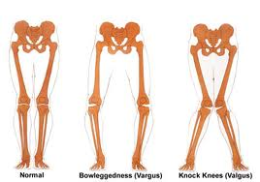

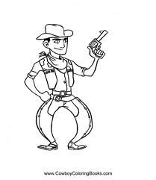

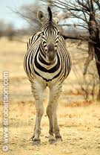

GENU VARUM

Bowlegged

Adverse Effects:
PF syndrome
Dislocations of patella

GENU VALGUM

Knock kneed

Adverse Effects:
PF syndrome
ACL injury

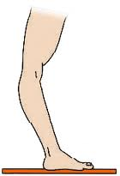

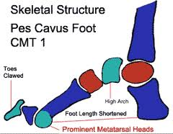

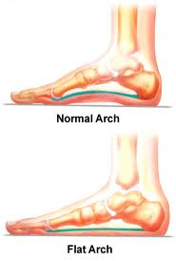

GENU RECURVATUM

Hyperextension

Adverse Effects:
ACL injury

PES CAVUS

High medial longitudinal arch

Adverse Effects:
Stress fractures
Plantar fasciitis
Heel Spur
Achilles tendon Injuries

PES PLANUS

Flat medial longitudinal arch

Adverse Effects:
Low back pain
Stress fracture
Shin splints
ACL injury

