Heat Therapy
Why Heat?
- Pain Control: Heat reduces pain producing chemicals by increasing blood flow to the area. Calms nerve endings but only short term. Effects start fading once heat is removed.
- Increased ROM: Heat increases collagen extensibility allowing muscles to be stretched further.
- Muscle Spasm Relief: Heat decreases muscle tone so spasms can relax.

When Should I heat?
- Before activity and static stretching to prevent injury.
- NEVER HEAT ACUTE INJURIES
  - Increases inflammation

Should I Stretch after?
- YES! Stretching should take place WITHIN 3 MINUTES after heat is removed for best results.
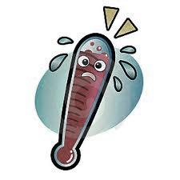
How long should I heat?
- 15-30 minutes
- Warming up can be achieved through moist heat packs, warm whirlpool, or exercise.

Can I burn myself?
- YES! Follow these steps to avoid injury:
  - Allow sufficient layering of towels between moist heat pack and body.
  - Never lay directly on moist heat pack.
  - Remove heat if it feels too hot.

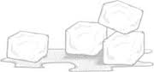
ICE TREATMENT
Why ICE?
- Pain Control: Cold numbs the area by interrupting pain signals to the brain and slowing down nerve transmission so it takes longer for the signal to be sent to the brain.
- Inflammation Control: Cold decreases cellular metabolism so not as much swelling is produced. Cold does not reduce swelling that is already present it just keeps more swelling from forming.

Types of Ice Treatment
- Ice Bag: Most convenient way to ice.
- Ice Bath: Allows athlete to ice angular areas and large areas.
- Ice Cup: Incorporates a massaging effect while icing to promote fluid reabsorption and muscle relaxation.
When Should I Ice?
- ACUTE INJURIES AND WHEN SWELLING IS STILL PRESENT
  - Never use heat on these injuries. Heat increases inflammation which impedes healing.
  - When in doubt. . . ICE!
- Preventative treatments should be performed after workouts at least once a day.
- Ice can be used once an hour as needed to relieve pain.

How Long Should I Ice?
- Ice Bag/Ice Bath: 20 min on 40 min off
- Ice Cup: 10 min on 40 min off

Will I get frostbite?
- NO if you follow these simple rules:
  - NEVER ICE MORE THAN 20 MINUTES (if directly on skin)
  - NEVER PUT CHEMICAL ICE PACK DIRECTLY ON SKIN

Normal Sensation Progression:
PainfulColdBurningAchingNumb
Electric Stimulation

What is it?
- E-Stim is a modality that uses electrical currents that stimulate sensory or motor nerves to achieve a therapeutic effect. Electrodes are placed around areas of pain or spasm and the electrical wave lengths travel back and forth between the two electrodes.
Electrode 1
Electrode 2

Why use it?
- Pain Control: Sensory nerves surrounding pain are stimulated to create a sensory overload that blocks the pain signal from being sent to the brain.
- Muscle Spasm Relief: Motor nerves are stimulated to contract and relax until exhaustion so the spasm is unable to continue and the muscle can completely relax.
- Muscular Reeducation: Motor nerves are stimulated to contract muscles while athlete consciously thinks about contracting muscle to recreate the motor pathway from the brain to the muscle. Usually used after surgery.

What does it feel like?
- Pins and needles that is strong yet tolerable
- Muscle contraction that is strong yet tolerable
- Should not be painful but is uncomfortable

Can I use this to increase strength?
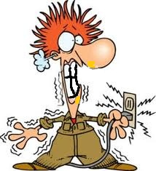
- NO. Muscle contraction would have to be so strong it would be too painful to use for increasing strength.

Will I be electrocuted?
- NO. Electrical current is too low to cause harm. The frequency of e-stim is different than major spinal nerves and sinus rhythms so e-stim will not adversely affect these nerves.

Ultrasound
What is it?
- Ultrasound is a therapeutic modality that is created from high frequency sound waves.
- Sound waves cause the molecules and cells in the tissue to vibrate which produces heat
- Heat increases blood flow to the area bringing vital nutrients that promote the healing process.
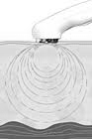

Is it the same as used on pregnant women?
- NO. This is therapeutic not diagnostic. Diagnostic ultrasound uses sound waves to produce a picture instead of heat and blood flow.
- Diagnostic ultrasound can also be used to visualize internal organs and structures to look for pathology.

Why do you use gel?
- When applied directly to the skin
  - Ultrasound head cannot effectively transfer sound waves into the body
- A conductive medium is required
  - The gel makes it possible for the sound waves to be transferred from the ultrasound head into the body
  - Ultrasound without gel is ineffective and can damage the ultrasound machine

What does it feel like?
- Depending on the settings you should either feel nothing or a slight warmth
- It should NEVER BE PAINFUL

Gate Control Theory
Picture

Pain Signal Inhibitory Neuron Gateway OPENS PAIN sent to
turns OFF Brain

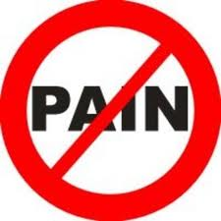
Pain signal
Inhibitory Neuron Gateway CLOSES
turns ON
Pressure/Movement/
Temperature

Theory:
- Before pain is sent to the brain it must pass through a gateway known as the inhibitory neuron. Pain turns off the inhibitory neuron and the signal is sent to the brain. Pressure, movement, and temperature also affect the inhibitory neuron. Pressure, movement and temperature turn on the inhibitory neuron blocking the pain signal from getting to the brain. These stimuli close the gateway so pain is unable to pass.

Practice:
- Modalities are used to turn on the inhibitory neuron to block the pain signal from getting to the brain. The goal of using modalities is to stimulate the senses that turn on the inhibitory neuron.
- Pressure: Ace bandage compression wraps
- Movement: Electric stimulation
- Temperature: Heat, ultrasound, and ice

