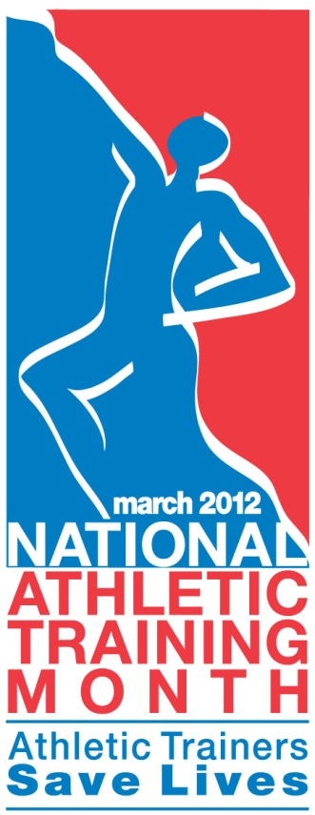
CERTIFIED ATHLETIC
TRAINERS

HEALTHY

ATHLETES!

AT MILLS COLLEGE

