The Anterior Cruciate Ligament
What is it?
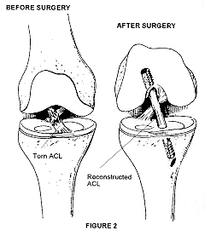
- One of 4 major ligaments of the knee
- Function is to stabilize the knee
  - Limits anterior translation of tibia
  - Helps limit internal rotation of the tibia
  - Helps limit hyperextension

Mechanism of Injury
- Planting and cutting
- Hyperextension
- Collision
- Sudden stopping
- Landing straight legged
- Anterior tibial translation
- More common in women
  - Why?
    - No one knows
  - Contributing factors
    - Increased Q angle (Genu Valgum)
    - Strength variation
    - Muscle recruitment variation
    - Improper landing technique
    - Hormones

Torn ACL. . . . Now What?

Surgery

Autograph Allograph

From Self From Other

Patellar tendon
Hamstring tendon
IT Band Fascia

Rehab
6-9 months

Return to Play

Non-Surgical

Knee will be unstable so must strengthen structure around ACL to compensate

Limited participation
- No running, Jumping, or Cutting

Knee can still do all the movements needed

Can lead to further damage of surrounding structures

Rehab
3-4 months

Brace highly recommended
Limited to biking, walking, etc

